Software Requirements Specification
for
Mapping For A Change
Version 1.01
Prepared by Scott Gibson
i-Search Kelowna
2018/02/05
Table of Contents
Table of Contents ii
Revision History ii
1. Introduction 1
1.1 Purpose 1
1.2 Document Conventions 1
1.3 Intended Audience and Reading Suggestions 1
1.4 Product Scope 1
1.5 References 1
2. Overall Description 2
2.1 Product Perspective 2
2.2 Product Functions 2
2.3 User Classes and Characteristics 2
2.4 Operating Environment 2
2.5 Design and Implementation Constraints 2
2.6 User Documentation 2
2.7 Assumptions and Dependencies 3
3. System Features 3
3.1 System Feature 1 3
3.2 System Feature 2 3
4. Other Nonfunctional Requirements 4
4.1 Performance Requirements 4
4.2 Safety Requirements 4
4.3 Security Requirements 4
4.4 Business Rules 4
Appendix A: Glossary 4
Appendix B: Analysis Models 5
Appendix C: To Be Determined List 5

Revision History
Name | Date | Reason For Changes | Version
Matthew Penner |  | Creation of Document | 1.0
Matthew | 03-09-2018 | Remove unneeded parts | 1.01
Devon Macneil | 03-18-2018 | User interfaces updated and requirements updated | 1.02
Scott Gibson | 04-02-2018 | Document finalization | 2.0

Introduction

Purpose
This is the software requirements for MFC version 1.00. The scope of the product is to produce an expanded feature for an already existing product. The feature is a reporting software that allows clients to gain a better understanding of what resources around them suit their needs. The reporting software is also designed to allow organizations to see what other organizations in the area are providing in terms of services. All of this is a proof of concept product.

Document Conventions
For the priority of the requirements, go to section 4 System Features.

Intended Audience and Reading Suggestions
The target audience for this document are as followed: Developers, project managers, documentation writers. The remaining portion of this document is meant to help understand what this subsection of the product does and why it is being created. For a resource in understanding where sections of the SRS are please consult the Table of Contents on page ii.

Product Scope
The purpose of the product is for the user to enter information/requirements they have and receive a detailed report about surrounding resources that would best accommodate them, as well as why those results were chosen. This will allow the user to better understand what resources they have available to them.

Additionally, organizations will be able to use this product in order to gain a better understanding about what services other organizations are providing.

References
No References are used.

Overall Description

Product Perspective
MFC is a research study created by Kerry Rempel MBA at the Okanagan College and the University of British Columbia. MFC is a branch of a current mapping application, iSearchKelowna, that tracks the housing resources in the Kelowna area. MFC will be focusing on creating dynamic reports for users, with detailed information and reasons why each resource was selected.

Product Functions
Major Functions:
- User must be able to enter information.
  - Most likely in a form layout.
- User must receive detailed report about services they can use.
  - Most likely in table layout.

User Class and Characteristics
There are two distinct user classes for this project. The first being a general user, and the second being an organization. For the general user, it is assumed they know the general process of filling out an online form. The document that is returned by the software is very straightforward and easy to read. For the organization, it is also assumed that they are able to fill out an online form. Both will have the same form, so there are no security differences between the two.

Operating Environment
The environment in which the software will operate is a website and thus run off a server. Due to this being a proof of concept this program will not have to coexist with any other application.

Design and Implementation Constraints
- As this is just a proof of concept, we are using a csv file to mimic the actual database.

User Documentation
- Software User Manual

Assumptions and Dependencies
It is assumed that the login credentials and security will be provided by the actual website.

External Interface Requirements

User Interfaces 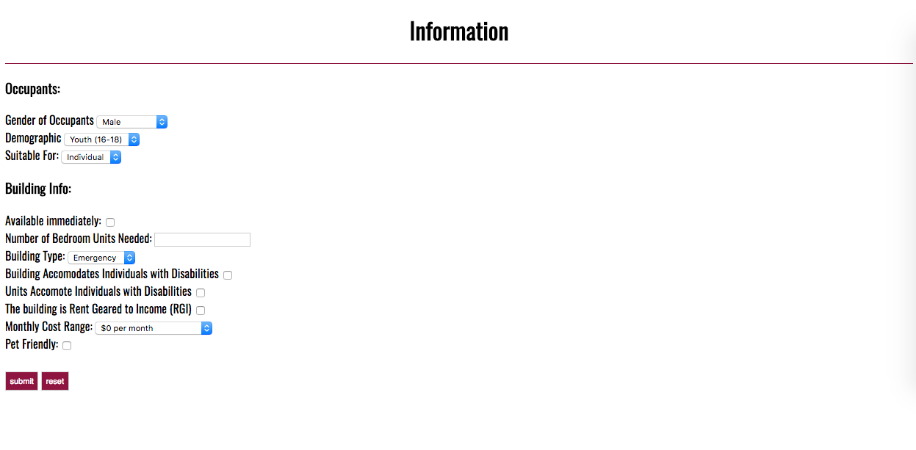
The user interface is simple. After the software is started the user is presented with this form. The user simply fills out the required information in the form and hits submit. After hitting submit the user is taken to a results screen that displays the query results. From here the user can download the results as a pdf or print the results.

Hardware Interfaces
The product interfaces with the user through basic computer hardware. The product is hosted on a web server. It is accessed by the user using a mouse or other device used to interact with computer software. The user inputs the required information using a keyboard or other data input devices designed for a computer.

Software Interfaces
This product uses the XAMPP stack, which provides us with PHP, MySQL, Linux Server, and Apache.

Communications Interfaces
The primary form of communication that the product requires is through the information input form. This allows the user to communicate with the server that the database is on so that the user may obtained the requested information. This is done using the standard post methods of html5.

System Features

Automatically generated client report
3.1.1 Description and Priority

This feature will return to the user a report based off information inputted by said user. The report will include some reasons why certain resources were picked for the user (example: distance, restrictions, help included, ect).

Priority: High
Benefit: 9
Cost: 7
Risk: 9

3.1.2 Stimulus/Response Sequences
The user must submit a form with all required information for the report to be generated (this is the user action).
3.1.3 Functional Requirements
REQ-1: If the client does not specifies any requirements the system will default to closest proximity.
REQ-2: The user must fill out a form with all required data. Before submitting a verification protocol will activate insuring all required information is inputted, otherwise it will stop the submission and ask the user to properly fill out the form.

Other Nonfunctional Requirements

Performance Requirements
The system must be able to compute requests, and return results, in a fashionable timeframe.
User Report Generation: 10 seconds.

Safety Requirements
Refer to Security Requirements for safeguards against loss of data. However if the data is taken and used by some other source, the only information that would be loss is inventory data of resources.

Security Requirements
The system must have security methods on both the front and back end of the product. Throughout the program’s runtime it must preprocess the information being sent as to make sure no malicious information is being sent (example: injection string into sql statement). All other security requirements will be handled by the main program, for which the MFC will be a subsection of.

Software Quality Attributes
The customer specified that the most important software quality attribute is the usability, specifically the ease of use. Someone should be able to easily use this software, and understand the form returned without having to be taught how to do so. This will allow new users and organizations to quickly and effectively use the software.

Business Rules
The user role will be able to submit a request form, with their information, and receive back a report about which services would best help them.

The organization role will be able to submit an update form and receive back a detailed report about what services other organizations in the area provide.
Appendix A: Glossary
User = People using the software.
Organization = Organizations providing housing in the database
MFC = Mapping for Change (Name of Software)
SRS = Software Requirements Specification Document
<…> = Anything inside is a description of what the section is about
Appendix B: To Be Determined List
<Collect a numbered list of the TBD (to be determined) references that remain in the SRS so they can be tracked to closure.>
2.7 Assumptions and Dependencies (Done to be reviewed)
3.1 User Interface (Done to be reviewed)
3.2 Hardware Interface (Done to be reviewed)
3.3 Software Interface
3.4 Communication Interface (Done to be reviewed)

